./



| Ver. Rel. No. | Release Date | Prepared. By | Reviewed By | To be Approved | Remarks/Revision Details |
| --- | --- | --- | --- | --- | --- |
| 1 | 9/9/2021 | Rajasheker Eajjagiri |  |  |  |
|  |  |  |  |  |  |
|  |  |  |  |  |  |
|  |  |  |  |  |  |
|  |  |  |  |  |  |

Details

**Contents**

**Contents 3**

**Miniproject -1 [Team/Individual]** **5**

**Module/s** **5**

**Topic and Subtopics** **5**

**Objectives & Requirements** **6**

**Design** **9**

**Test Plan** **9**

**Implementation Summary** **10**

**Video Summary** **10**

**Git Link** **10**

**Git Dashboard** **10**

**Summary** **11**

**Individual Contribution & Highlights** **12**

**Summary** **12**

**Challenges faced and how were they overcome** **17**

**Future Scope (If applicable)** **17**

**Miniproject -2 [Team/Individual]** **0**

**Module/s** **0**

**Topic and Subtopics** **0**

**Objectives & Requirements 0**

**Design** **0**

**Test Plan** **0**

**Implementation Summary** **0**

**Git Link 0**

**Git Dashboard** **0**

**Summary** **0**

**Individual Contribution & Highlights** **0**

**Summary** **0**

**Challenges faced and how were they overcome** **0**

# Miniproject -1 [Individual]

Airlines Ticket Booking System - Spring Boot Tool Suite , Mysql,HTML,CSS,Java,Boot Strap,SDLC etc...

### Topic and Subtopics

“Briefly list the core topics and subtopics being implemented and how”

Airlines Ticket Booking System consists of an airline's department account called the “Admin” module and “User” module. Admin can login to the Admin page with credentials and Add flight details,update flight details and also provide flight details to users. whereas a new User can go to the Signup page for Registration with his/her personal details.After completing the registration process ,User can login with his/her credentials like email id as a username and mobile number as password. Personal email id that can be used only once then the user password is encrypted even admin can't see it.User can able to see all the flight details by using **View Flights** page,based on his/her schedule or available time book the ticket by using **Book Ticket** page by adding booking (journey) information like Flight Number,Flight Name,From(present location/source) ,To (destination), Date of journey,Time, Number of tickets.

When a user wants to book a ticket by clicking on the book button it will show selected(ordered) seats,price of tickets as total Amount and also shows available tickets and asking for payment as proceed for payment,when user clicks on proceed for payment(click Here) ,it will go to the **Payment** page. In the payment page by adding Bank Name,Card Number,Expiry date ,CVV and Amount details then click on payment,after the completion of successful payment only, the user was able to book the ticket successfully.User can also update/edit his/her personal details by using **Update Details** page.

**Objectives & Requirements**

**High level requirements**

* All the pages are linked and it consists of User(user details),Flight(flight management details),Ticket(Booking details),Payment(payment details) tables.
* Only authorized users can access the Login and User Home pages by using their credentials.
* Total tickets are 250, If the user booked 250 tickets then it shows Tickets are Full.
* In case,the user wants to book more than 250 tickets then it will show available tickets are 250 only, your ordered tickets are more than 250 and also shown as your exceeding (cross) the limits.
* Implemented Registration page which includes image insertion.

**Low level requirements**

* One email id can used only once and password will be encrypted even admin can't see it
* Once a user booked a flight ticket with the number of tickets then it will calculate the amount and show the remaining seats.
* It consists of two modules, those are User and Admin.

**TABLES**:

**Flight Table**:

| **Field Name** | **DataType** | **Key** |
| --- | --- | --- |
| Flight Number | Varchar(255) | Primary |
| Flight Name | Varchar(255) |  |
| From(Source) | Varchar(255) |  |
| To(Destination) | Varchar(255) |  |
| Date | LocalDate |  |
| Time | LocalTime |  |

**User Table**:

| **Field Name** | **DataType** | **Key** |
| --- | --- | --- |
| Email | Varchar(255) | Primary |
| Name | Varchar(255) |  |
| Gender | Varchar(255) |  |
| Date Of Birth | Date |  |
| Mobile Number | Long |  |
| Address | Varchar(255) |  |
| Image | Byte |  |
| Role | Varchar(255) |  |

**Ticket(Booking ) Table:**

| **Field Name** | **DataType** | **Key** |
| --- | --- | --- |
| Ticket Id | Long | Primary |
| From | Varchar(255) |  |
| To | Varchar(255) |  |
| Flight Number | Varchar(255) | Foreign |
| Flight Name | Varchar(255) |  |
| Date Of Journey | Date |  |
| Departure Time | Time |  |
| Ticket Type | Varchar(255) |  |
| Number Of Tickets | Integer |  |

**Payment Table:**

| **Field Name** | **DataType** | **Key** |
| --- | --- | --- |
| Payment Id | Long | Primary |
| Bank Name | Varchar |  |
| Card Number | Long |  |
| Expiry Date | Date |  |
| CVV | Long |  |
| Ticket Id | Long | Foreign |
| Amount | Long |  |

## 

## **Design:**



## 

## 

## **Test Plan :**

* Once a user booked a flight ticket then it will calculate the amount based on the number of tickets and type of tickets and also show the remaining seats.
* Total tickets are 250, If the user booked 250 tickets then it shows Tickets are Full.
* In case,the user wants to book more than 250 tickets then it will show available tickets are 250 only, your ordered tickets are more than 250 and also shown as your exceeding (cross) the limits.

## 

## 

## **Implementation Summary**

User can able to see all the flight details by using **View Flights** page,based on his/her schedule or available time book the ticket by using **Book Ticket** page by adding booking (journey) information like Flight Number,Flight Name,From(present location/source) ,To (destination), Date of journey,Time, Number of tickets.

When a user wants to book a ticket by clicking on the book button it will show selected(ordered) seats,price of tickets as total Amount and also shows available tickets and asking for payment as proceed for payment,when user clicks on proceed for payment(click Here) ,it will go to the **Payment** page. In the payment page by adding Bank Name,Card Number,Expiry date ,CVV and Amount details then click on payment,after the completion of successful payment only, the user was able to book the ticket successfully.User can also update/edit his/her personal details by using **Update Details** page.

### Video Summary

“Please upload a short video on the repo for the walkthrough of the project (Team/Individual) less than 7 min and less than 30MB File Size. Start is the Standard opening slide with the title of mini project + Team members followed by the walkthrough ”.

I uploaded a video by following the above mentioned guidelines.

### Git Link

“https://github.com/RajashekerEajjagiri/Intern-Mini-Project.git”

### 

### 

### 

### 

### Summary

Airlines Ticket Booking System consists of an airline's department account called the “Admin” module and “User” module. Admin can login to the Admin page with credentials and Add flight details,update flight details and also provide flight details to users. whereas a new User can go to the Signup page for Registration with his/her personal details.After completing the registration process ,User can login with his/her credentials like email id as a username and mobile number as password. Personal email id that can be used only once then the user password is encrypted even admin can't see it.User can able to see all the flight details by using **View Flights** page,based on his/her schedule or available time book the ticket by using **Book Ticket** page by adding booking (journey) information like Flight Number,Flight Name,From(present location/source) ,To (destination), Date of journey,Time, Number of tickets.

When a user wants to book a ticket by clicking on the book button it will show selected(ordered) seats,price of tickets as total Amount and also shows available tickets and asking for payment as proceed for payment,when user clicks on proceed for payment(click Here) ,it will go to the **Payment** page. In the payment page by adding Bank Name,Card Number,Expiry date ,CVV and Amount details then click on payment,after the completion of successful payment only, the user was able to book the ticket successfully.User can also update/edit his/her personal details by using **Update Details** page.

#### **Git inspector summary**

“In linux install gitinspector and Run the command –

gitinspector -H -l -m -T -w -r --grading --format=html > gitinsp.html

and upload the same to your repo and paste the snapshot in the report”

#### **Build**

“Brief on outcome of the build and setup done”

#### **Code quality and Issues or Bug Tracking**

“Brief on code quality, errors and warnings flagged (issues created) and fixed ”

#### **Unit Testing**

“Unit Testing setup alignment with test plans and summary of outcome”

## **Individual Contribution & Highlights**

This project was completely done individually.

### Summary

### Airlines Ticket Booking System is a Java project which maintains the ticket booking and other works of Airlines. This system is very much easy and is user-friendly. Anyone can use this system without any difficulty. As back-end support MySQL database is used and Spring Boot Tool Suite(STS) IDE and for Front-end development ,I used bootstrap and CSS. Before you run this project make sure you have the JDK and JRE installed on your system.Talking about the project, this project does all the kind of activity that a flight requires. This Airlines ticket booking system does all the necessary things. The system demonstration is by the admin, Here users can simply book the flight ticket. For this, he/she has to choose the travelling destination and the route through which they will travel.

### 

### 

**Home Page:**

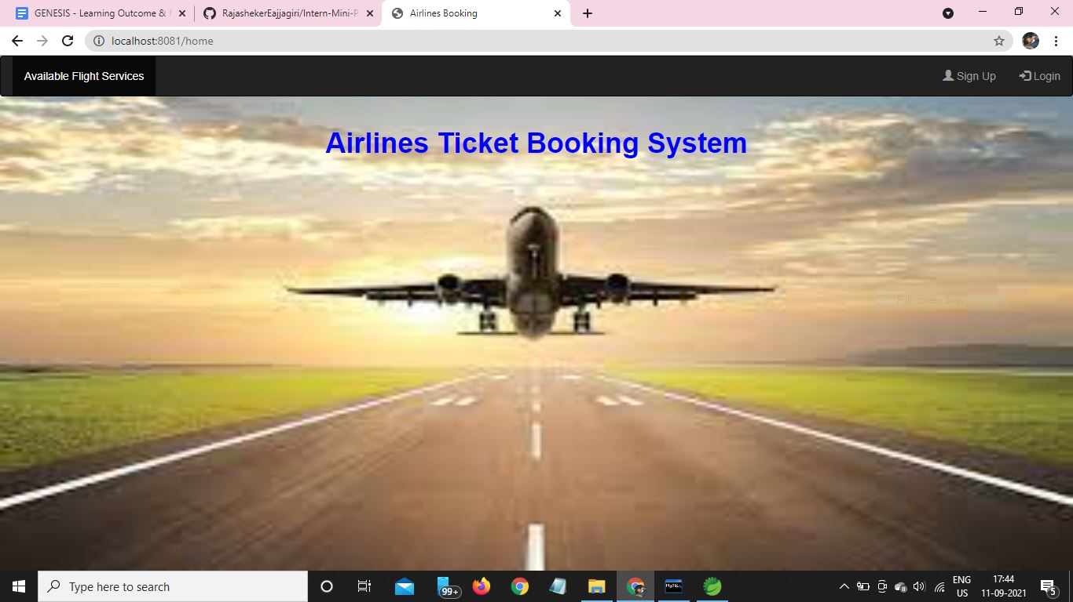

**Available Flight Services:**

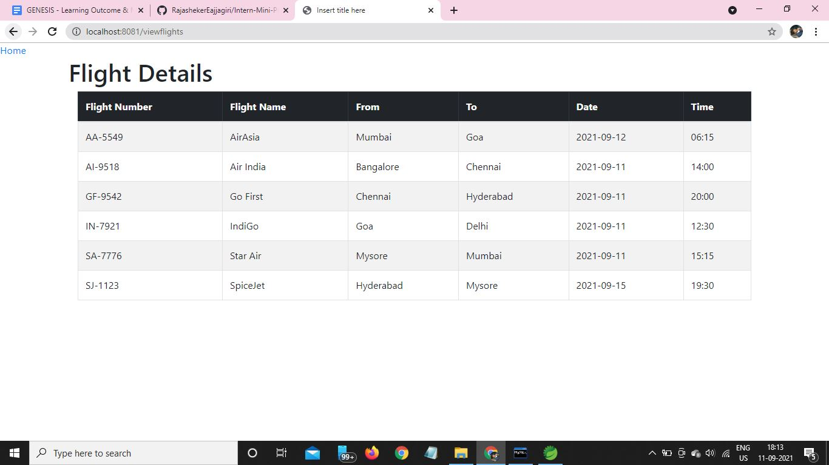

**Registration Page:**

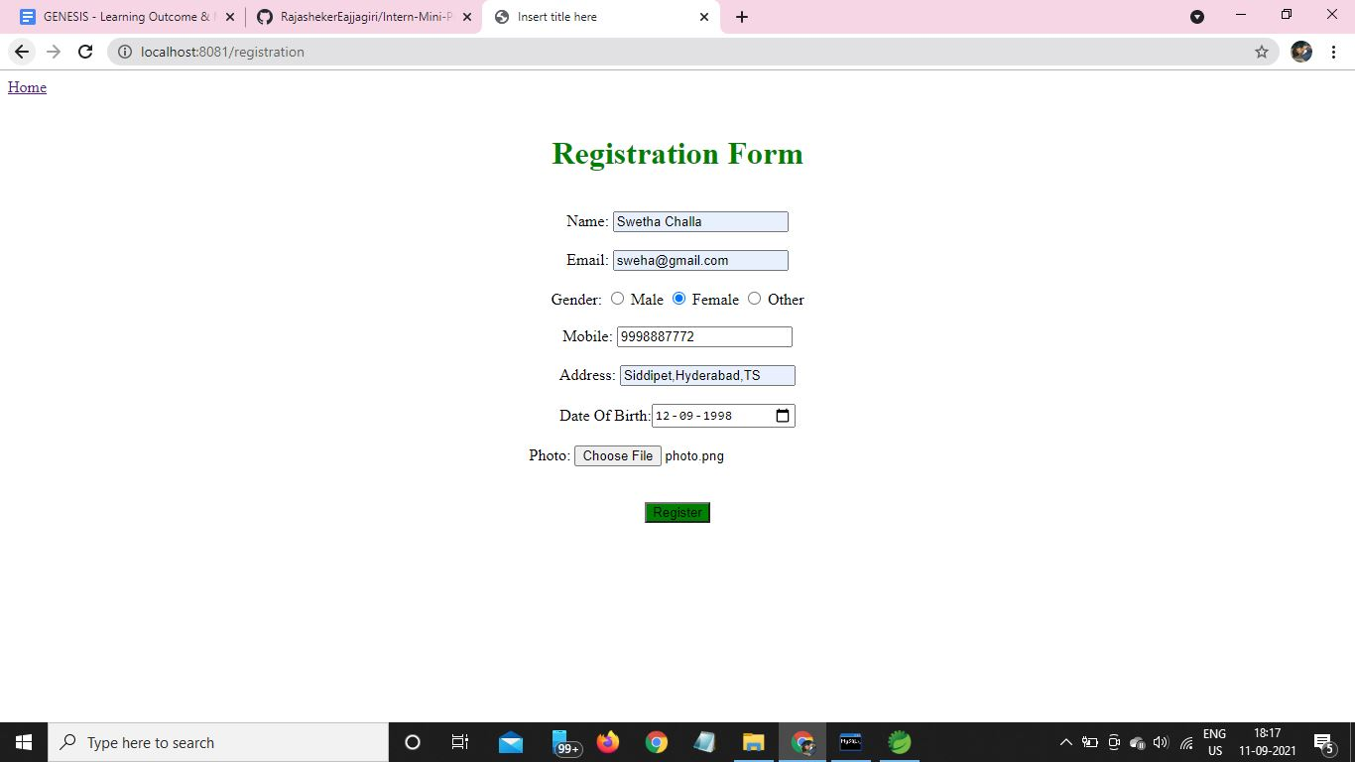

**Login Page:**

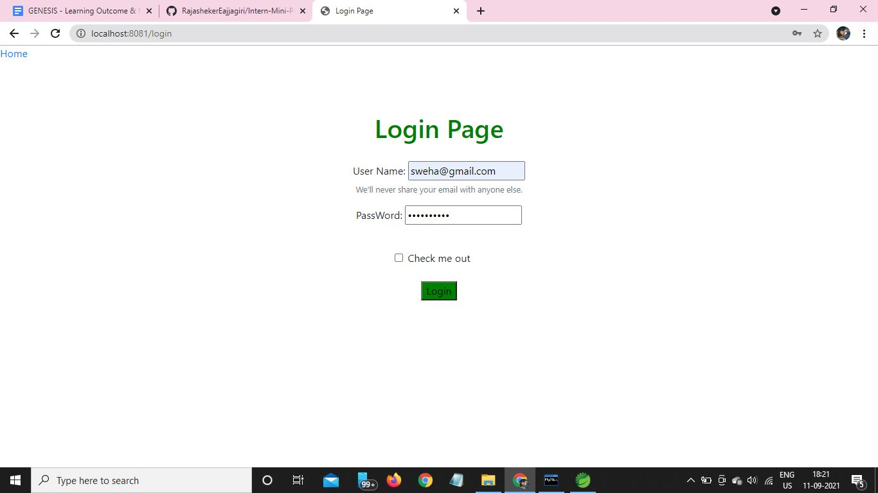

**AdminHome Page:**

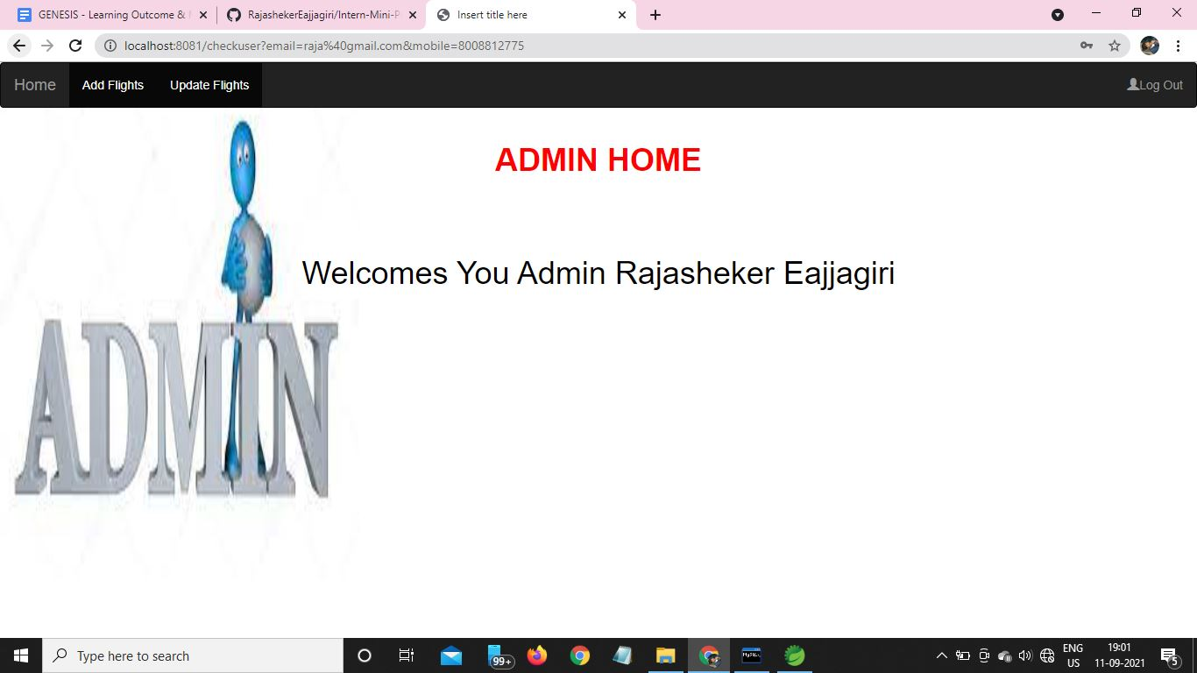

**UserHome Page:**

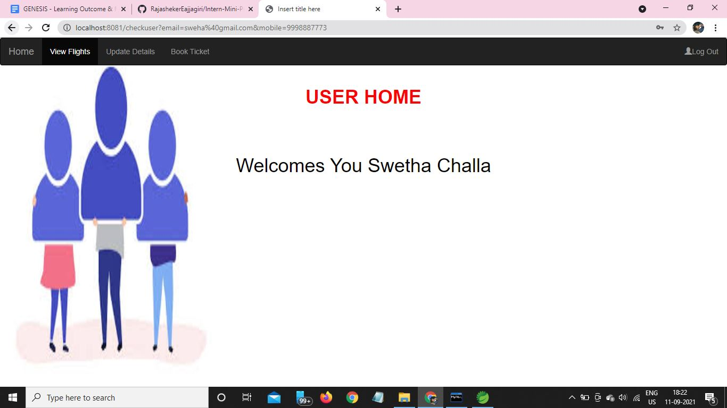

**Booking Flight Ticket:**

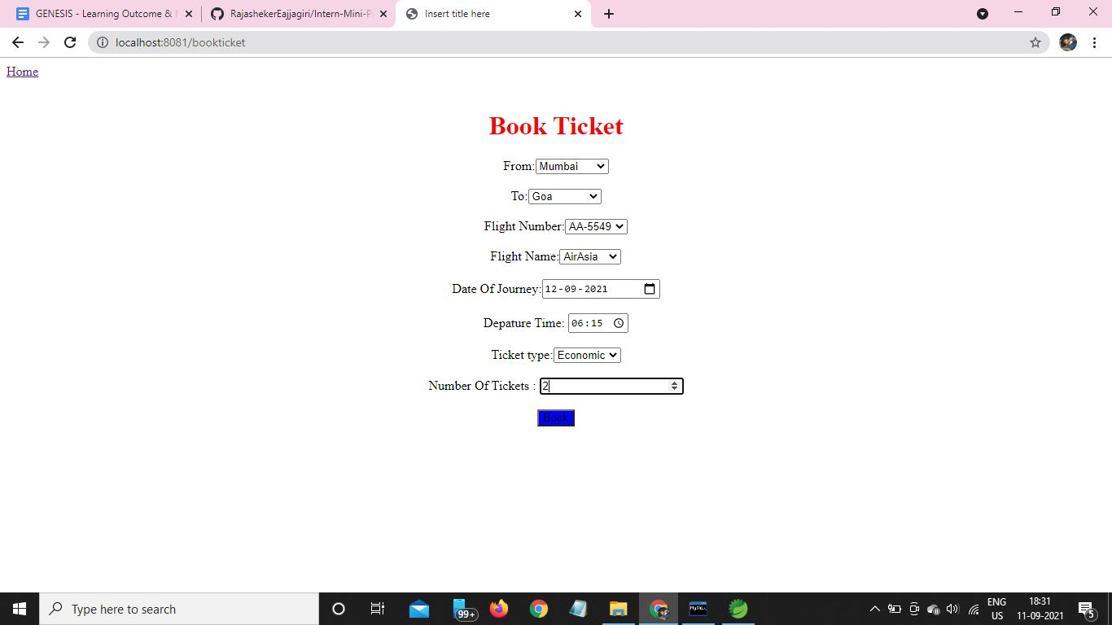

**Available Tickets**:

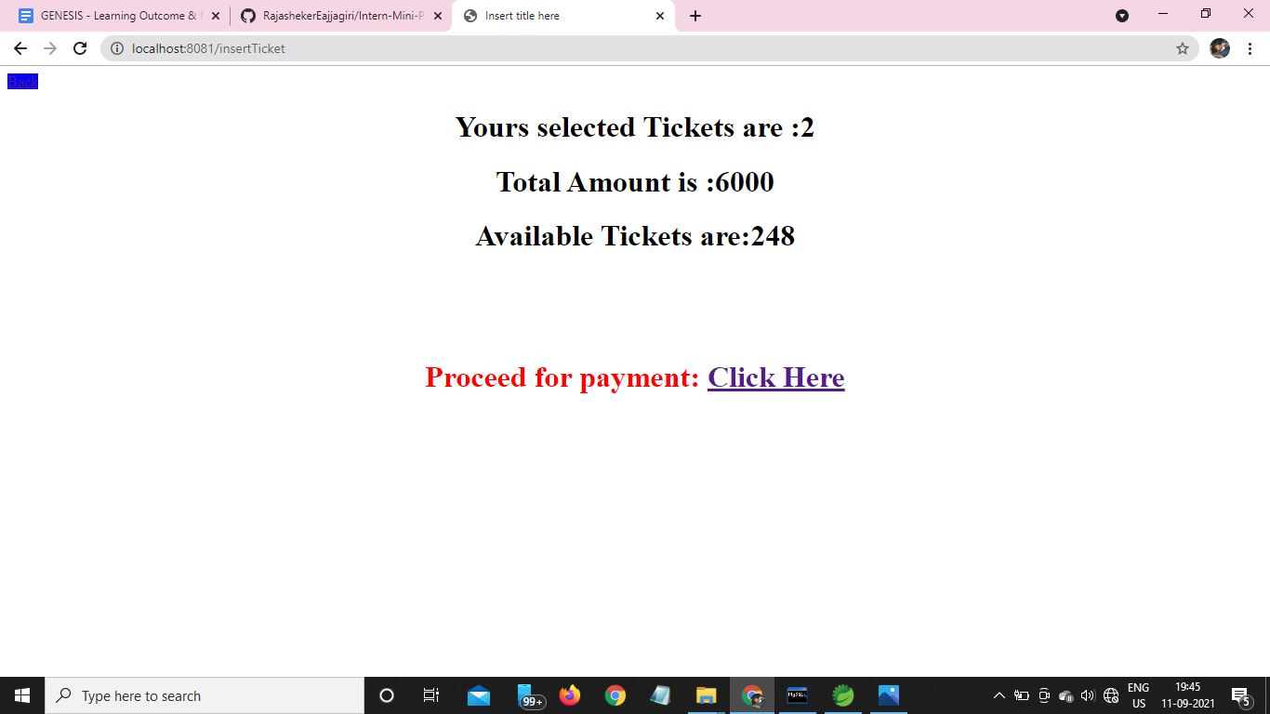

**Payment Page:**

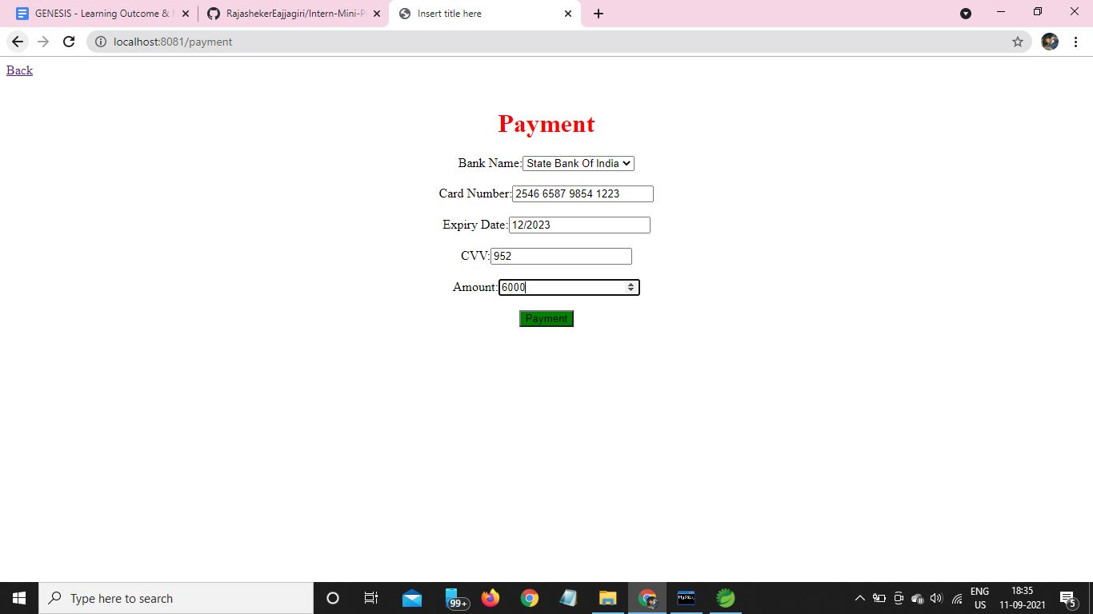

### Challenges faced and how were they overcome

Challenges that I have faced are while importing of images and implementing spring security to the application.

### Future Scope (If applicable)

In the future I will try to add email two step verication and sending ticket details to the mail by using SMTP protocals .

### 